LAB 2A in Mac OS

1. Pre-Lab

In Mac OS, We first touch a hello.txt and then edit the hello.txt by vim.At last, we can see the document through cat.

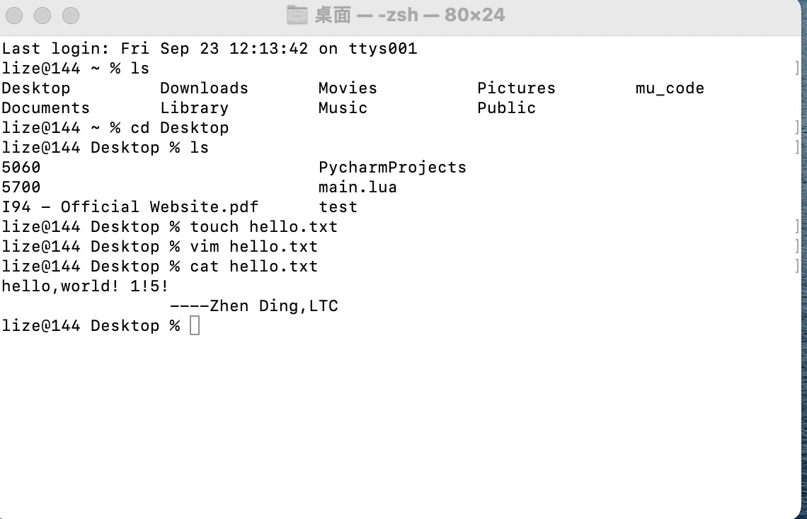

1. Setting Lab 2 A

First, Install Homebrew

/bin/bash -c "$(curl -fsSL [https://raw.githubusercontent.com/Homebrew/install/HEAD/install.sh)"](https://raw.githubusercontent.com/Homebrew/install/HEAD/install.sh)\")

Second, Export Homebrew to environment path:

1. cd ~(open ~directory)
2. If we don’t have .zshrc document, we need to creat in ~~directory by touch .zshrc
3. open or vim .zshrc to edit the file
4. add two exports to the file

export PATH=/opt/homebrew/bin:$PATH

export PATH=/opt/homebrew/sbin:$PATH

1. source .zhsrc
2. brew -v to check.If the HomeBrew is successfully export to environment, we will look the version of HomeBrew.

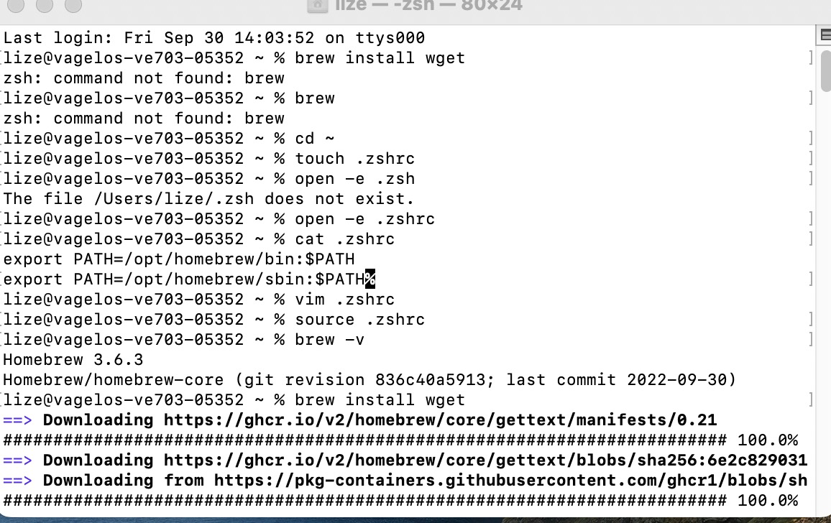

Third, From the above figure, we need to install the wget by

brew install wget

Fourth, install the toolchain:

brew install cmake

brew tap ArmMbed/homebrew-formulae

brew install arm-none-eabi-gcc

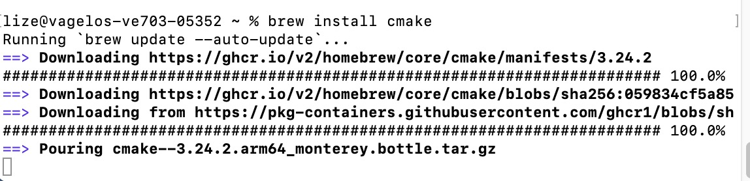

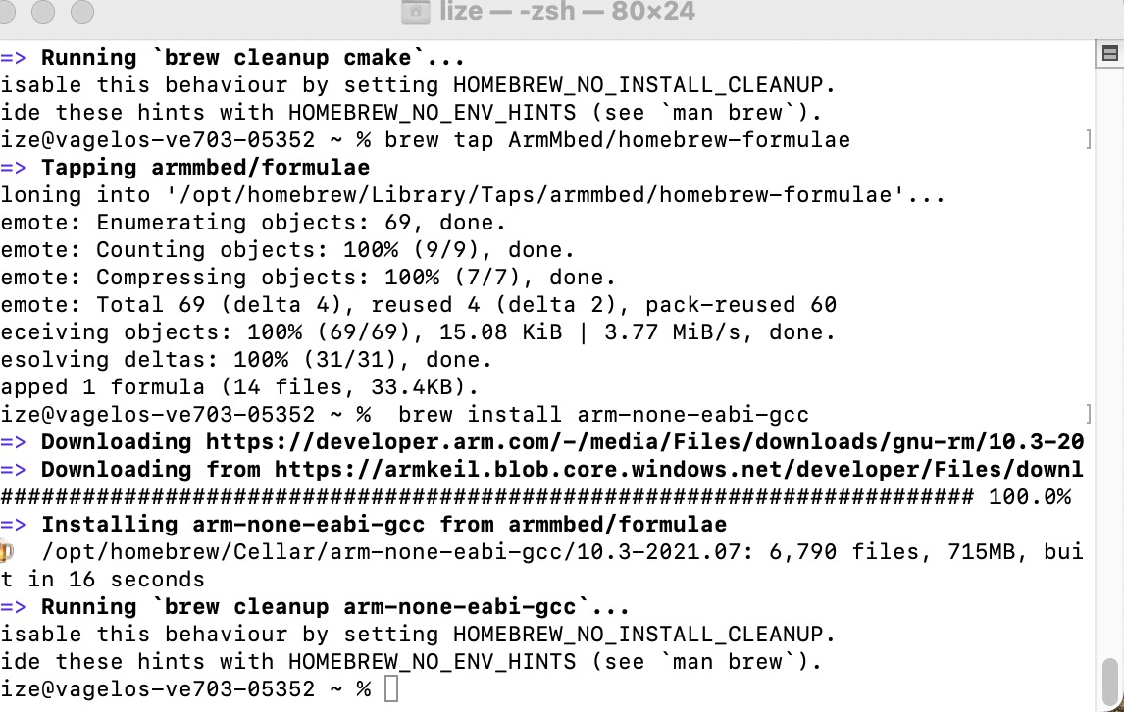

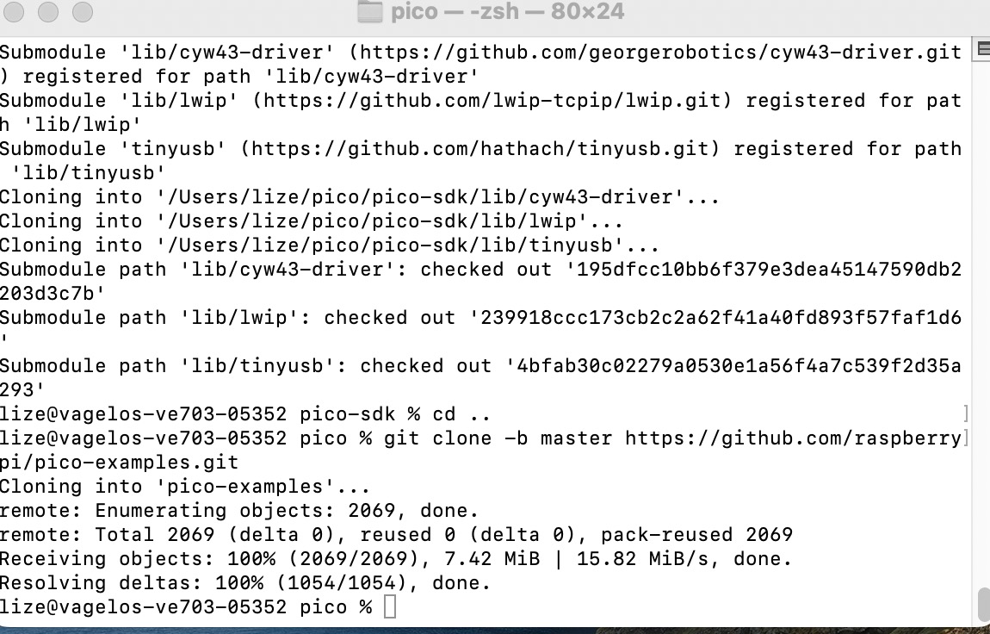

Then, set environment in VsCode

**By following the guidence in document *Getting start with Raspberry 9.1*:**

(1)After starting Visual Studio Code you then need to install the CMake Tools extension. Click on the Extensions icon in the left-hand toolbar (or type Cmd + Shift + X), and search for "CMake Tools" and click on the entry in the list, and then click

on the install button.

1. We now need to set the PICO_SDK_PATH environment variable. Navigate to the pico-examples directory and create a .vscode directory and add a file called settings.json to tell CMake Tools to location of the SDK. Additionally point Visual Studio at the CMake Tools extension.

{   "cmake.environment":

{   "PICO_SDK_PATH":"../../pico-sdk"   },

}

1. Then go to the File menu and click on "Add Folder to Workspace…" and navigate to pico-examples repo and click "Okay". The project will load and you’ll (probably) be prompted to choose a compiler, Select "GCC for arm-noneeabi"

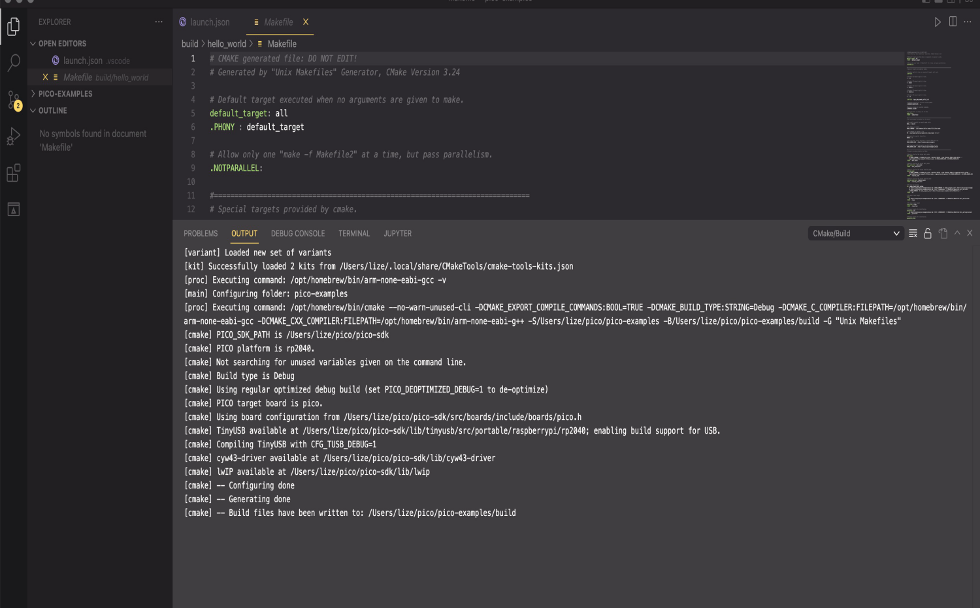

1. clicke the bulid botton we can see:

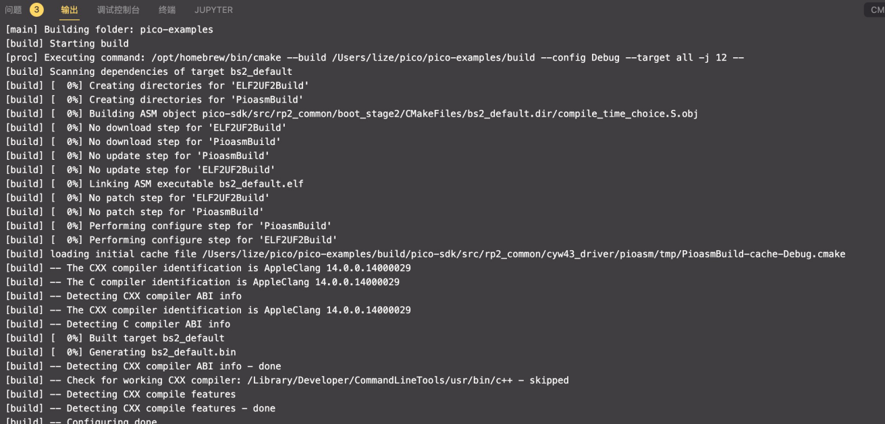

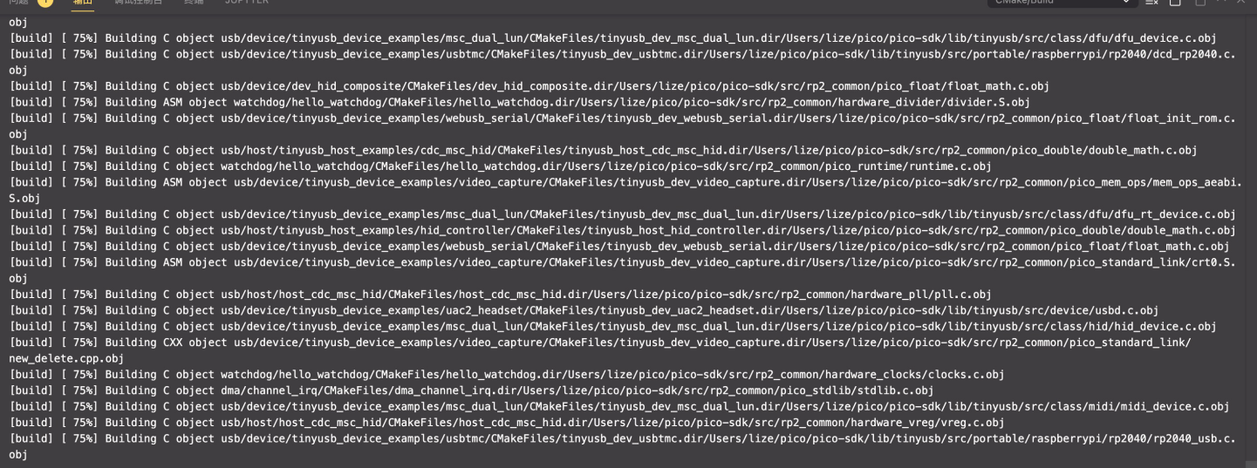

In the end, we need to Drag and drop hello_usb.uf2 onto the Mass Storage Device from the

pico-examples/build/hello_world/usb/

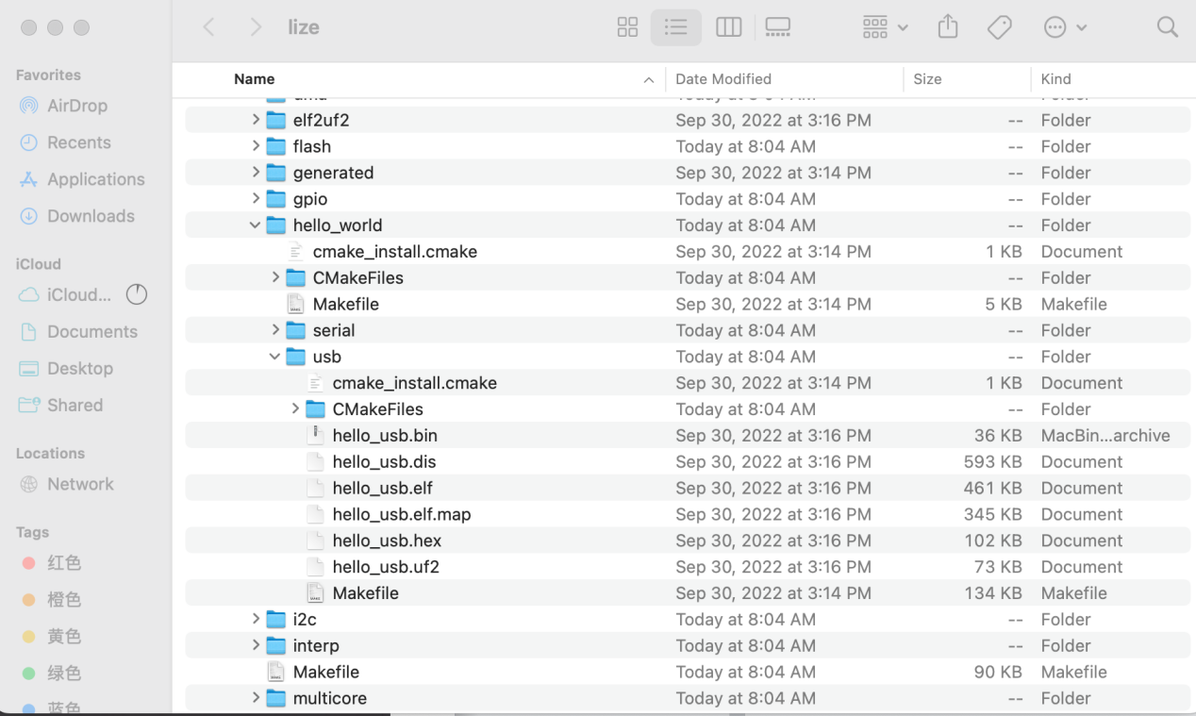

Then, open the terminal and link to the screen .

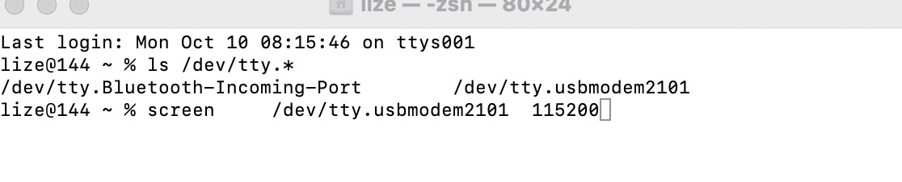

we can see that

